Steps for Volume creation in Docker
1.
2.
3. 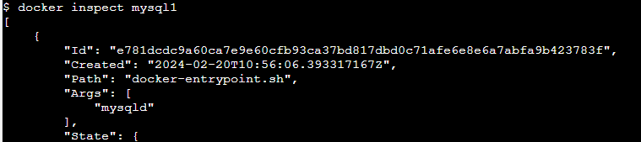
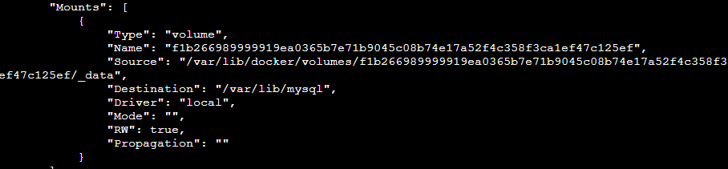
4. 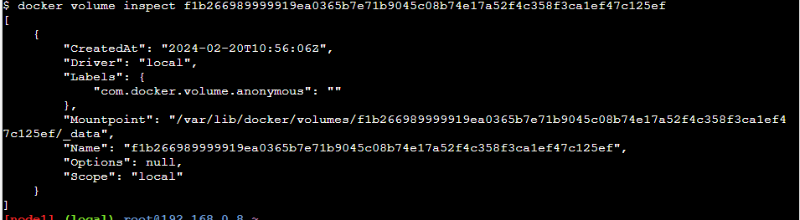

5. 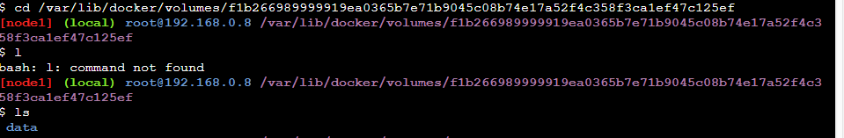
6.
7.
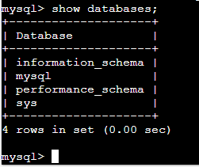
8. Remove the container
Docker rm -f <container id>

9. create new container again
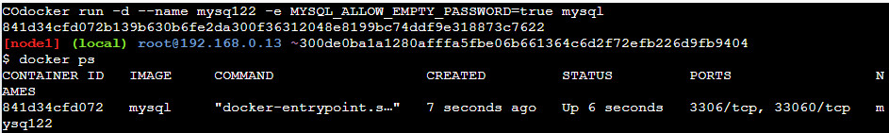

10. check the data inside this container in bash
Docker –it exec <container id> bash
Inside
>mysql
Mysql> show databases;
<previous database not exist>

11. now link the old volume for new container as:
12.
Now enter in running container and check databases
All previous databases will be retrived
